Nested Loops on 2d Array Manipulation

Media Computation Lab (Picture Lab from APCS)

# Main Objectives

* Use nested loops to traverse 2D arrays.
* Manipulate objects mathematically to produce desired results on digital images.

# Prior Knowledge

* Familiarity with calling methods on objects.
* Familiarity with looping structures.
* Familiarity with 2d arrays in accessing length of rows, columns, and individual elements.
* Optional challenge problems: binary bitwise manipulation operation (not on APCSA exam).

# Greenfoot Background

The original published version of this lab, PictureLab was designed by Barbara Erickson of the Georgia Institute of Technology. It has become one of the three standard labs of the APCSA course work. The intention of this version is to modify the setup of the lab to work more seamlessly for teachers who use Greenfoot. The knowledge level needs of Greenfoot is quite limited here. Greenfoot has a specialized Color API, similar to Java.awt but slightly different. This Color API makes up the main Greenfoot background knowledge needed. For one optional challenge problem the MouseInfo API knowledge from Greenfoot is required.

# Getting Started

Install the Greenfoot IDE: <https://www.greenfoot.org/download>

* Greenfoot went through many changes beginning with the 3.0.0 release. Version 2.4.2, although older, tends to be one of the most stable versions but is missing a few of the newer additions.
* **The older Greenfoot versions did not include a Color class**. If using an older version at the top of your World codes add: import java.awt.Color; The rest of the code will remain the same.

In your Media Computation folder run the project file with the Greenfoot icon to begin.

# Instructions

The instructions are written directly in the Canvas class as comments for each of the tasks. Students will be writing many methods with descriptions and visuals shown below. Each task is independent of the next and should be tested before moving on.

To test any individual method return to the Greenfoot PictureLab window, right click the background, and choose the method to test.

# Extensions and Modifications

* This lab can be done without using 2d arrays and instead using nested loops. The exercises remain exactly the same, but for each method students would begin with the following:

GreenfootImage bg = getBackground();

Students would then loop through the image’s width and height values as needed, grab a single Color at a single coordinate, calculate the new Color to place, then set the Color at a single coordinate. The conceptual knowledge is the same but can be done before learning 2d arrays. This leads to a secondary goal of doing the same project with 2d arrays in the future to reinforce the knowledge

* Many additional methods may be created for the MediaComputation lab. Some examples: Shrinking a secondary image into 1/4th its size and placing it in one of the corners of the original image. Blurring the whole image by average pixels near each other. Calculating the closest corner of the color cube for each pixel and setting that pixel to that closest color (red,green,blue,yellow,cyan,magenta,white,black). The challenge problem of hiding one picture in another picture is already described in the lab. Hiding chars into each pixel using binary bitwise operators then being able to pull those chars back out to see the hidden messages. Students could come up with their own exercises.

#### Weird Gradient Demo (Left in to view as a starting point)

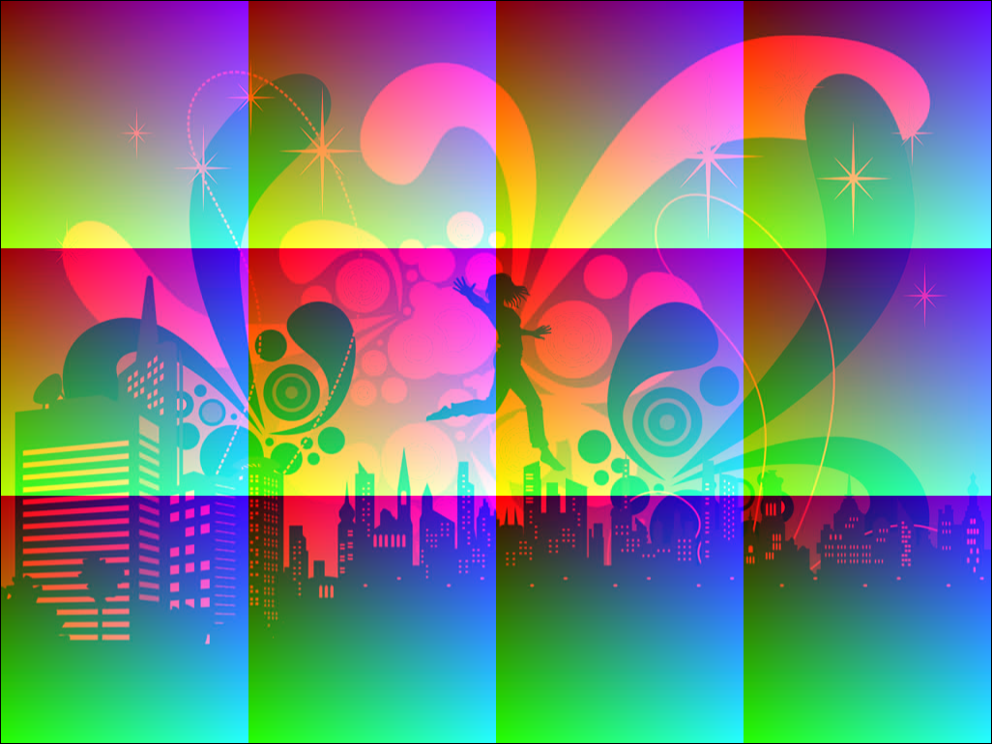

#### Randomize All Pixels



#### Randomize Solid



#### Randomize Rows

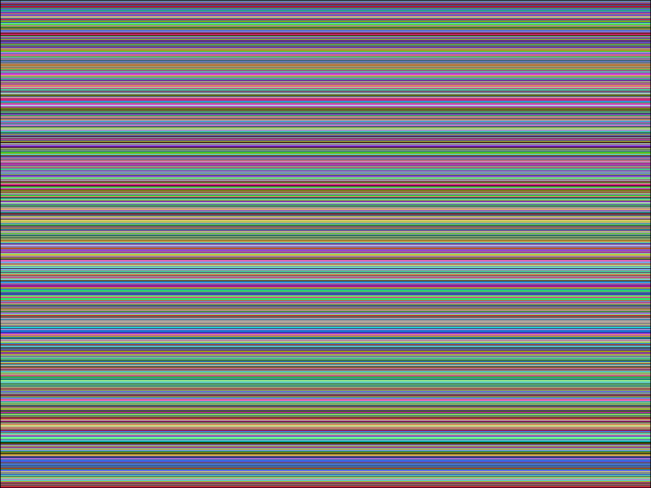

#### Randomize Columns

#### 

#### Brighter (Shown Called Twice Here)



#### Darker (Shown Called Twice Here)



#### Invert

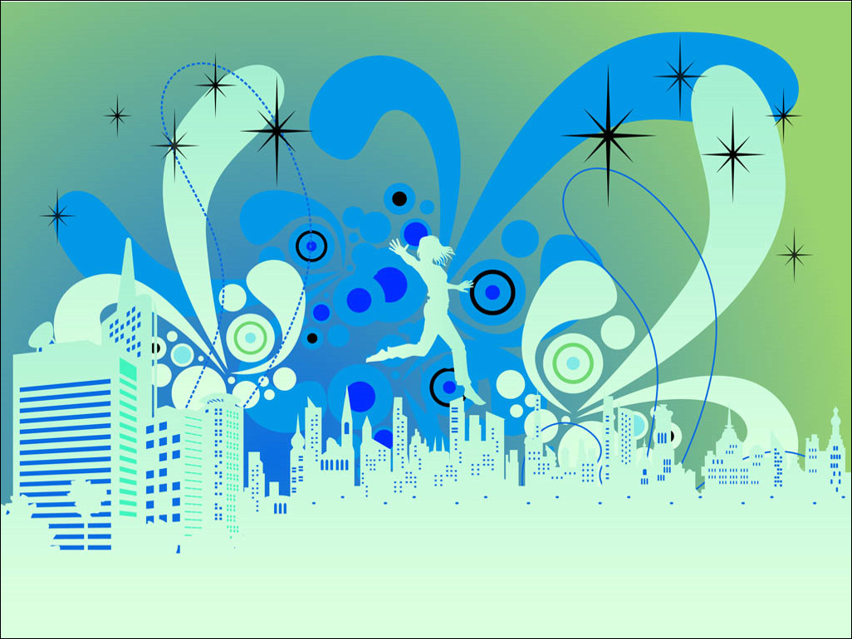

#### Invert Red

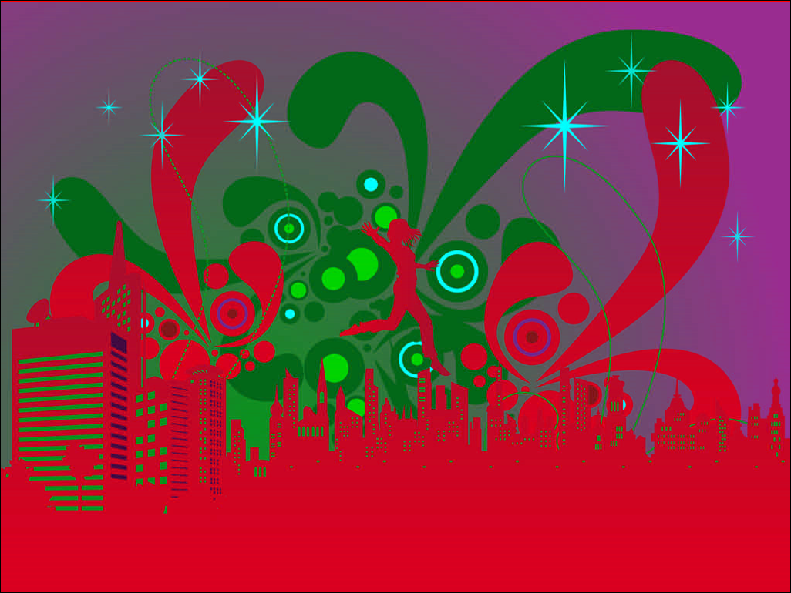

#### Invert Green

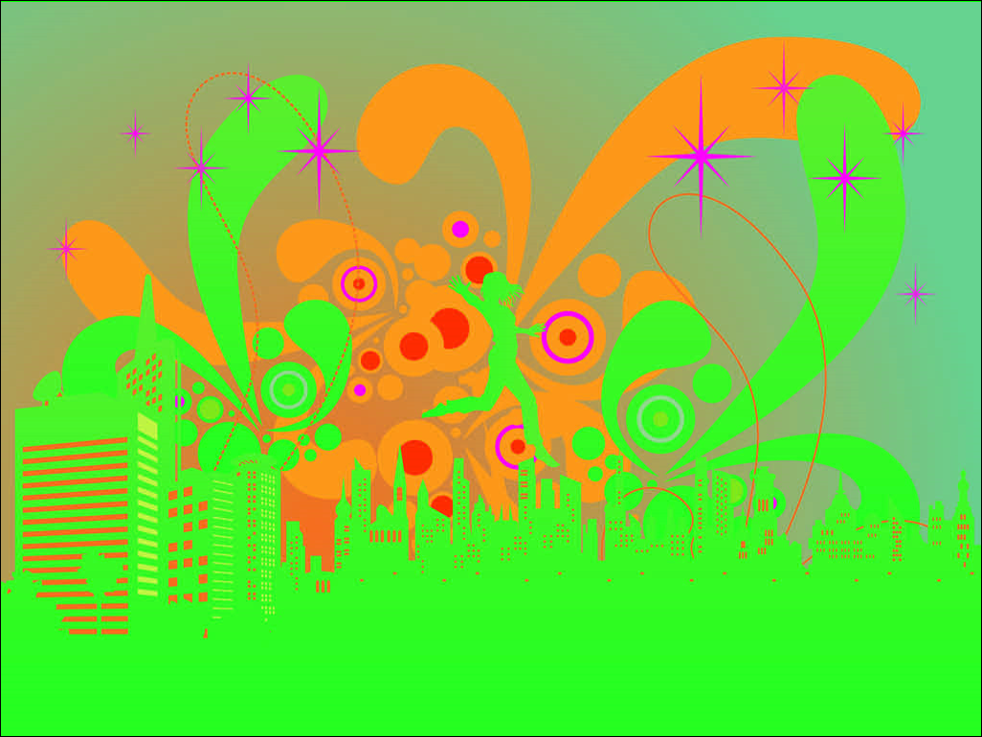

#### Invert Blue



#### Grayscale



#### Red Scale



#### Red-Gray Scale



#### Green Scale



#### Green-Gray Scale



#### Blue Scale

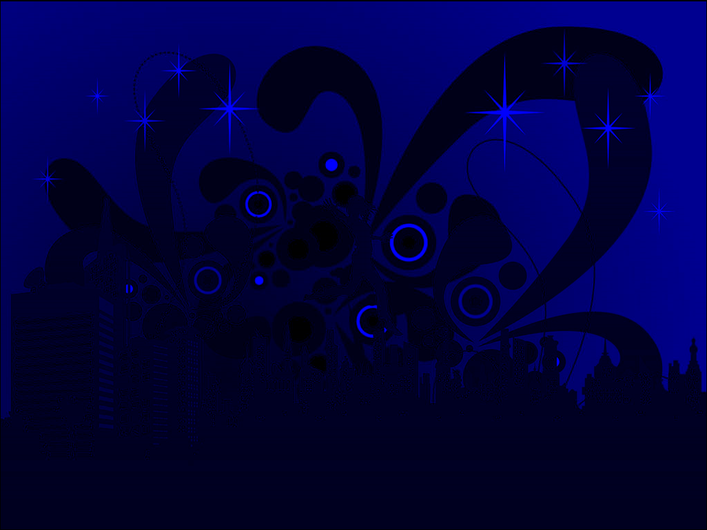

#### Blue-Gray Scale



#### Mirror Top to Bottom

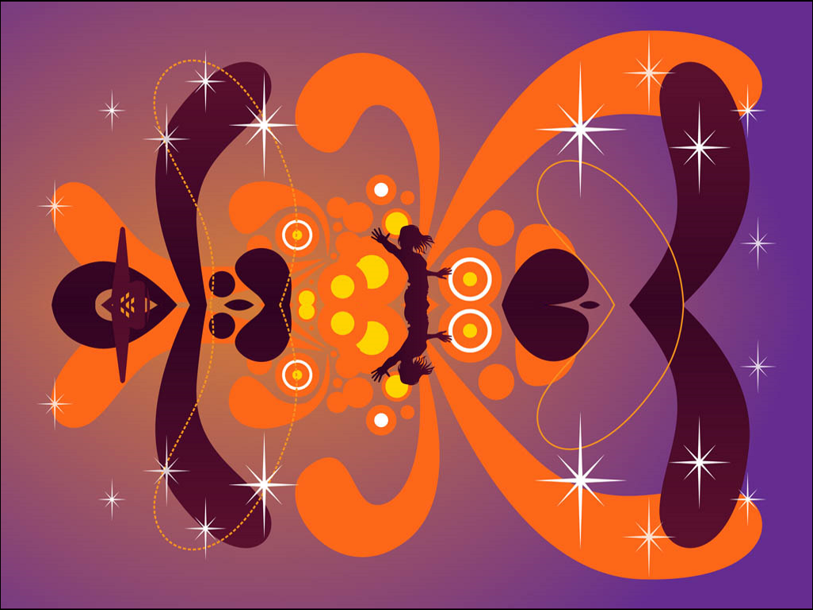

#### Mirror Bottom to Top

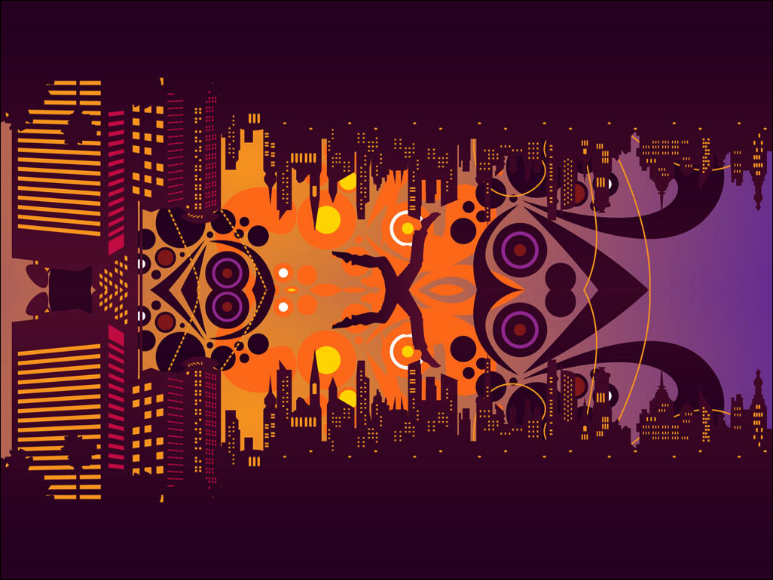

#### Mirror Left to Right



#### Mirror Right to Left



#### Flip Horizontal



#### Flip Vertical



#### Detect Edges (Shown with a threshold value of 20 here)

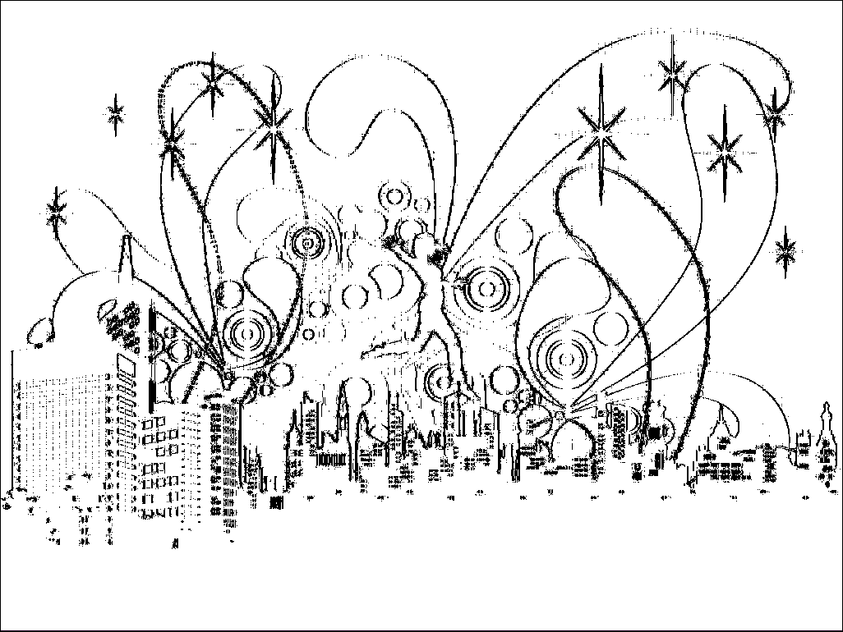

#### Pixelate (Shown with an input value of 4 here)

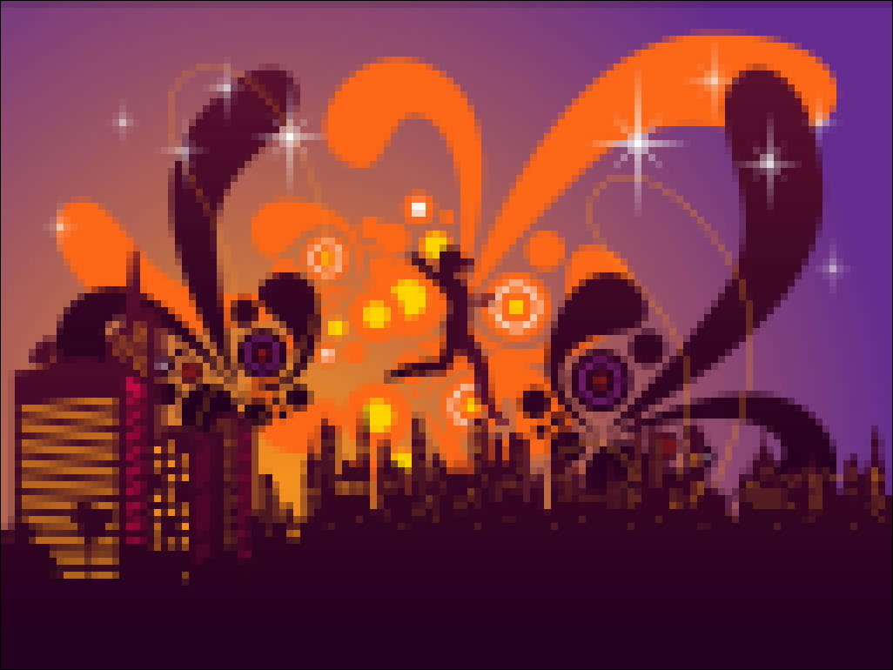

#### Hide Image / Bit Exchange (Can you see one image inside the other?)



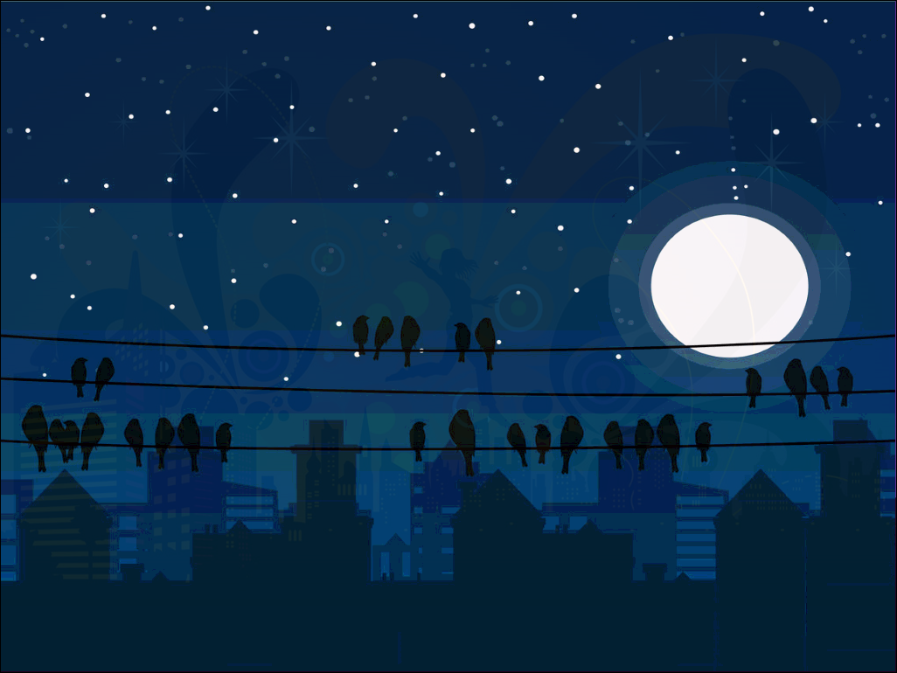

#### Draw (Lets the mouse draw on the screen while the program is running)

